Registering and logging in

Registering a new account

Open your web browser and go to www.cityofblueridgega.gov. Click on the Asset Essentials Citizen Portal link. In order to use Asset Essentials you will need to create an account. This will allow you to track the progress and receive feedback on your request.
- click the button to Accept Disclaimer .
- Click Sign In/Register in the navigation menu.

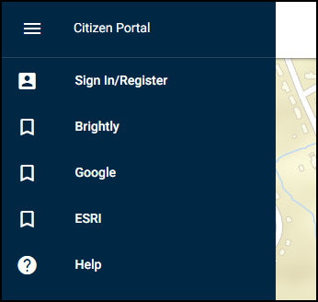

- Enter your Email address. *Note: Your email address will be your login name.
- Enter a Password and confirm it.
- Enter your First Name and your Last Name.
- Click the Submit button. *Note: After registering, you will receive an email from Asset Essentials asking you to activate your account. You must click the link in the email before you are able to sign in with your new credentials.

Logging into the citizen portal
If you already have a Citizen Portal account set up, you are able to log in to view existing requests or create a new request.

- Open your web browser and go to www.cityofblueridgega.gov. Click on the Asset Essentials Citizen Portal link or use the link on your desktop/mobile device if you have saved it.
- If you have not already done so, bookmark this page or create a shortcut on your desktop to make it easy to come back to this page later.
- If applicable, click the Accept Disclaimer button.
- On the next screen, you will see a map. Select Sign In/Register in the navigation menu.

- Enter your user name in the Choose a User list.
- Enter your Password and click Sign In. *Note: Check the Remember Me box to stay signed into your account for 14 consecutive days on your mobile device or web browser.

