Submitting and viewing work requests
You are able to create work requests directly from the map by selecting a location or by entering an address or landmark in the upper right hand corner.

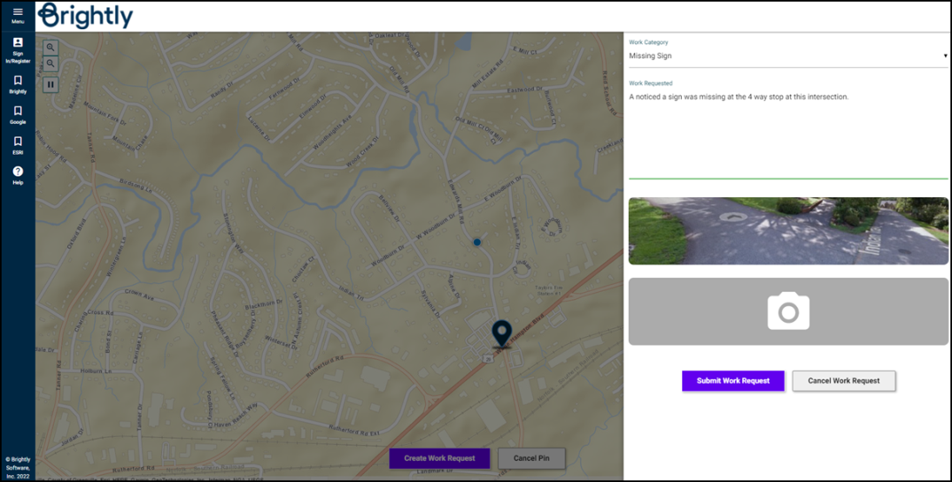

Submitting a new request
From the map, click on the location for which you would like to submit the request. Once you have selected your location, you will see a GPS pin at that spot.

- Click Create Work Request at the bottom of the map.

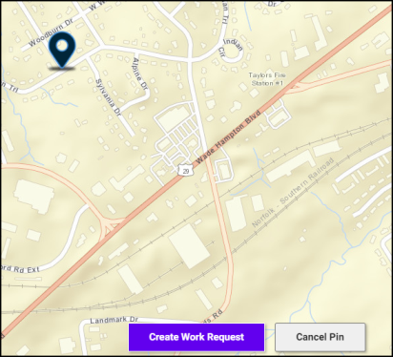

- In the side panel, select the Work Category that best describes what type of work needs to be done.
- Depending on which Work Category was selected, you may be asked to select the appropriate Site related to your request.
- Enter a description with details regarding the request in the Work Requested field.
- If you have photos you would like to attach, click on the camera image. You will have the option of choosing a photo from your computer or photo gallery if you are using a mobile device. *Note: There is no limit to how many photos can be attached to the request however, the maximum file size is 10MB.
- Once all of your details have been entered, click on Submit Work Request.

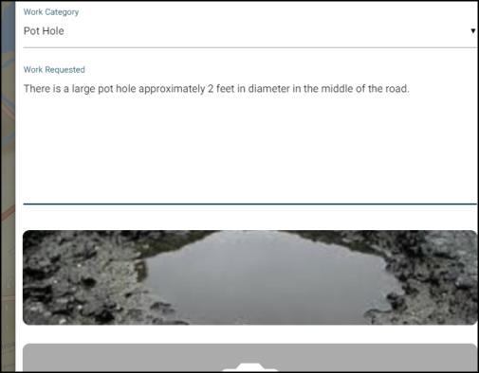

- If you are not currently logged in, a pop-up message will prompt you to click the Sign In/Register button to either log into your account or create a new one. *Note: If you would like to track the status of your request you must have a Citizen Portal account.

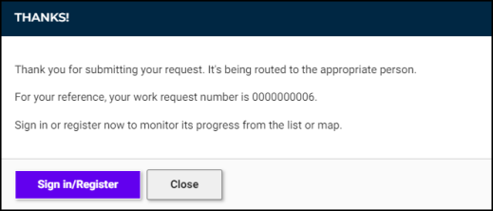

Viewing work requests
You must have created an account to view existing work requests.

- Be sure you are logged into your Asset Essentials Citizen Portal account, and select Show My Requests from the menu.

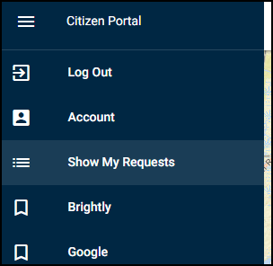

- A side panel will open displaying the requests you have submitted. Click on a request to view additional information. *Note: Once a request has been submitted, you are not able to make any changes to it. You are only allowed to add additional photos.

